Even, odd and periodic functions

A periodic function is one that repeats itself. The period is the difference in x values after which the graph repeats itself
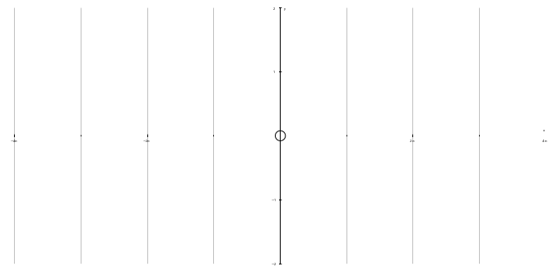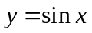

An even function is one which is symmetrical in the y axis: 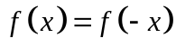
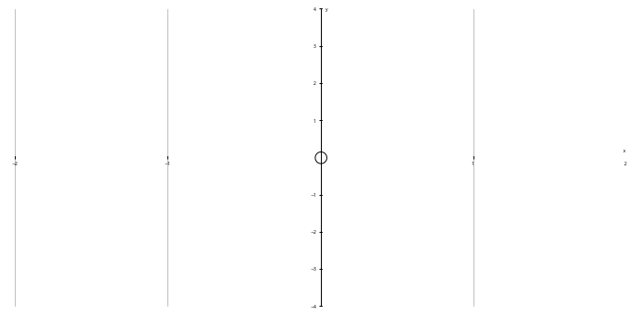

An odd function is one which has rotational symmetry of order 2 about the origin: 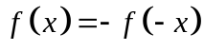
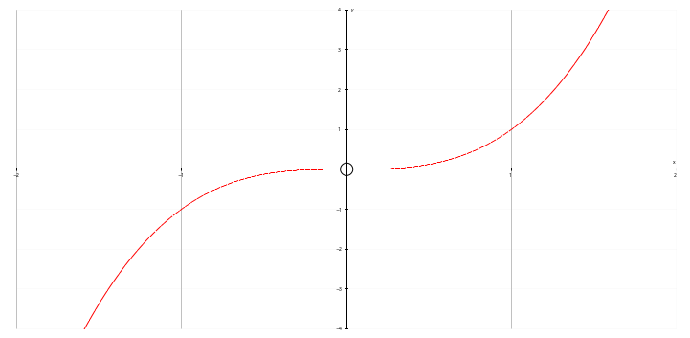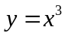

Example

(a) 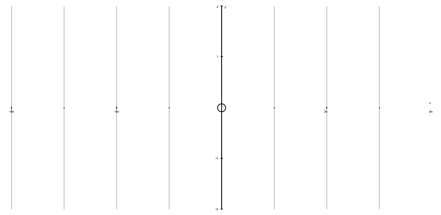 (b) 